**Lab 5: Retrieval of records from single table**

________________________________________________________________________

**Objective:** The student will understand the concept of DML statements.

**Course Outcome CO1:** Students will be able to use select statement to retrieve rows from a single table. (using relational and logical operators, renaming of attributes, order by, like, between etc.)

**Blooms Taxonomy Level**: BT1, BT2. BT3

1. Retrieve employee name, employee salary and date of joining for the employees working for department no. ‘D02’.

Sol:-

show databases;

Use Lab_03;

select ename , esal , edoj

from employee

where dno = 'd02';

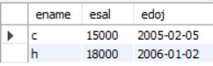

1. Find the complete details of the projects ordered by client no ‘C02’.

Sol:-

show databases;

Use Lab_03;

Select* from client

where clno = 'c02';



1. Find the dependent name, dependent relation and dependent date of birth for employee no ‘E08’.

Sol:-

show databases;

Use Lab_03;

Create table Dependent (eno char(3), dpname varchar(20), dpdob date, dprelation varchar(20));

Insert into Dependent(ENO,DPNAME,DPDOB,DPRELATION)values('e02','ab','1965-03- 01','father'),('e02','bc','1980-08-02','brother'),('e03','dc','1989-07-02','son'),('e03','bc','1989-07- 02','daughter'),('e05','ef','1960-01-06','mother'),('e06','fg','1950-07-07','daughter');

select DPNAME , DPDOB , DPRELATION

from Dependent

where ENO = 'e08';



1. Retrieve the employee name and employee salary for the employees whose department is D01 or have salary more than 20000.

Sol:-

show databases;

Use Lab_03;

Create table Employee (eno char(3), ename varchar(20), eadd varchar(30), ephone char(8), esal int, grade char(1), edoj date, dno char(3), emgrno char(3));

Insert into Employee(ENO,ENAME,EADD,EPHONE,ESAL,GRADE,EDOJ,DNO,EMGRNO)values('e01','a','Delhi',' 12345',60000,'C','2006-01-01','d01',''),('e02','b','Ggn','231456',20000,'B','2006-01- 02','d01','e01'),('e03','c','Fbd','341566',15000,'A','2005-02- 05','d02','e02'),('e04','d','Fbd','789012',5000,'A','2004-06- 03','d03','e03'),('e05','e','Ggn','345234',6000,'A','2008-08- 03','d04','e07'),('e06','f','Delhi','123876',25000,'B','2005-05- 03','d03',''),('e07','g','Fbd','785634',9000,'A','2006-05- 08','d04','e08'),('e08','h','Ggn','895634',18000,'A','2006-01-02','d02','');

select ENAME , ESAL

from Employee

where DNO = 'd01';

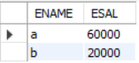

1. Retrieve the employee name and phone number for the employees whose address contains Ggn or Fbd and have grade B.

Sol:-

show databases;

Use Lab_03;

Create table Employee (eno char(3), ename varchar(20), eadd varchar(30), ephone char(8), esal int, grade char(1), edoj date, dno char(3), emgrno char(3));

Insert into Employee(ENO,ENAME,EADD,EPHONE,ESAL,GRADE,EDOJ,DNO,EMGRNO)values('e01','a','Delhi','12345',60000,'C','2006-01-01','d01',''),('e02','b','Ggn','231456',20000,'B','2006-01-02','d01','e01'),('e03','c','Fbd','341566',15000,'A','2005-02-05','d02','e02'),('e04','d','Fbd','789012',5000,'A','2004-06-03','d03','e03'),('e05','e','Ggn','345234',6000,'A','2008-08-03','d04','e07'),('e06','f','Delhi','123876',25000,'B','2005-05-03','d03',''),('e07','g','Fbd','785634',9000,'A','2006-05-08','d04','e08'),('e08','h','Ggn','895634',18000,'A','2006-01-02','d02','');

select ENAME , EPHONE

from Employee

where EADD = 'Ggn' && GRADE = 'B';



1. Find the employee numbers along with the project numbers for employees who working on a project between 6 to 10 hrs.

Sol:-

show databases;

Use Lab_03;

Create table Proj_alloc (eno char(3), pno char(3), hrs int);

Insert into Proj_alloc(ENO,PNO,HRS)values('e01','p01','4'),('e02','p02','6'),('e02','p03','3'),('e03','p03','2'),('e04','p02','8'),('e06','p01','9'),('e05','p02','10'),('e05','p03','20'),('e07','p05','4'),('e08','p05','6'), ('e08','p06','8'),('e04','p03','7');

select PNO

from Proj_alloc

where HRS >'6' && HRS < '10';

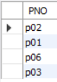

1. Find the employee name, department number and salary they draw in increasing order of department number and decreasing order of salary.

Sol:-

show databases;

Use Lab_03;

Create table Employee (eno char(3), ename varchar(20), eadd varchar(30), ephone char(8), esal int, grade char(1), edoj date, dno char(3), emgrno char(3));

Insert into Employee(ENO,ENAME,EADD,EPHONE,ESAL,GRADE,EDOJ,DNO,EMGRNO)values('e01','a','Delhi','12345',60000,'C','2006-01-01','d01',''),('e02','b','Ggn','231456',20000,'B','2006-01-02','d01','e01'),('e03','c','Fbd','341566',15000,'A','2005-02-05','d02','e02'),('e04','d','Fbd','789012',5000,'A','2004-06-03','d03','e03'),('e05','e','Ggn','345234',6000,'A','2008-08-03','d04','e07'),('e06','f','Delhi','123876',25000,'B','2005-05-03','d03',''),('e07','g','Fbd','785634',9000,'A','2006-05-08','d04','e08'),('e08','h','Ggn','895634',18000,'A','2006-01-02','d02','');

select ENAME , ESAL , DNO

from Employee

order by ENAME , ESAL DESC , DNO ASC;

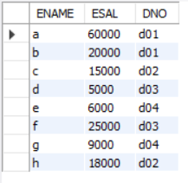

1. Find the employee names and their address for the employees who do not have any manager.

Sol:-

show databases;

Use Lab_03;

Create table Employee (eno char(3), ename varchar(20), eadd varchar(30), ephone char(8), esal int, grade char(1), edoj date, dno char(3), emgrno char(3));

Insert into Employee(ENO,ENAME,EADD,EPHONE,ESAL,GRADE,EDOJ,DNO,EMGRNO)values('e01','a','Delhi','12345',60000,'C','2006-01-01','d01',''),('e02','b','Ggn','231456',20000,'B','2006-01-02','d01','e01'),('e03','c','Fbd','341566',15000,'A','2005-02-05','d02','e02'),('e04','d','Fbd','789012',5000,'A','2004-06-03','d03','e03'),('e05','e','Ggn','345234',6000,'A','2008-08-03','d04','e07'),('e06','f','Delhi','123876',25000,'B','2005-05-03','d03',''),('e07','g','Fbd','785634',9000,'A','2006-05-08','d04','e08'),('e08','h','Ggn','895634',18000,'A','2006-01-02','d02','');

select ENAME , EADD

from Employee

where EMGRNO = ' ';

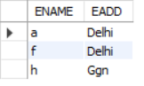

1. Find the client number who have ordered projects which have ‘e’ in their name.

Sol:-

show databases;

Use Lab_03;

Create table Project (pno char(3), pname varchar(30), pstdate date, clno char(3));

Insert into Project(pno , pname , pstdate , clno) values('p01','ab','2006-01-01','c01'),('p02','bc','2006-02-01','c02'),('p03','cd','2006-04-20','c02'),('p04','de','2004-04-01','c03'),('p05','ef','2005-05-02','c04'),('p06','fg','2006-02-03','c03');

select clno

from Project

where pname like '%e%';

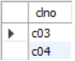

1. Find the department names and their corresponding location for the departments having head other than e03 and e05.

Sol:-

show databases;

Use Lab_03;

Create table Department (dno char(3), dname varchar(20), dloc varchar(20), dhead char(3));

Insert into Department(DNO,DNAME,DLOC,DHEAD) values('d01','finance','Delhi','e01'),('d02','accounts','Fbd','e03'),('d03','personal','Ggn','e05'),('d04','marketing','Delhi','e06');

select DNAME , DLOC

from Department

where DHEAD != 'e03' and DHEAD!='e05';

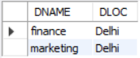

**LAB – 6**

1. Find the employee’s name, their salary and address for employees having a manager.

select ename, esal, eadd, emgrno from employee where emgrno is not NULL;

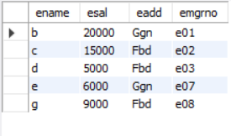

1. Find the employee number along with the dependent name who are daughter.

select eno, dpname from dependent where dprelation = 'daughter';

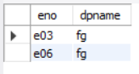

1. Find the client number and client names who are situated either in Fbd or Ggn.

select clno, clname, cladd from client where cladd in ('Fbd', 'Ggn');

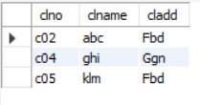

1. Find the project names who have been ordered by either client no c01 or c03.

select pname, clno from project where clno in ('c01', 'c03');

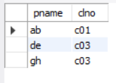

1. Display the employee name and salary under the heading

Employee Name Employee Salary

for the employees who do not belong to department d01 and d03.

select ename as Employee_Name, esal as Employee_Salary, dno from employee where dno not in ('d01', 'd03');

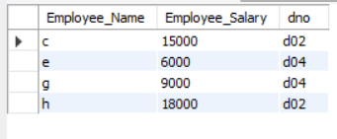

1. Find the complete details of the projects ordered by client no ‘C02’.

select * from project where clno = 'c02';

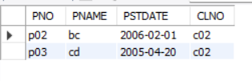

1. Find the dependent name, dependent relation and date of birth of dependents of employee named ‘c’.

select dpname, dprelation, dpdob from dependent, employee where (dependent.eno = employee.eno) and (ename = 'c');

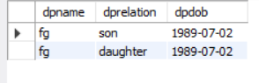

1. Retrieve or find the employee name, employee salary, department name for the employees whose department is located at Ggn.

select ename, esal, dname from employee, department where (employee.dno = department.dno) and (dloc = 'Ggn');

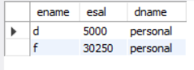

1. Find the employee numbers who are working on the project named ‘cd’.

select eno from project, proj_alloc where (project.pno = proj_alloc.pno) and (pname = 'cd');

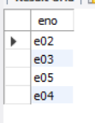

1. Find the project names which are ordered by ‘def’ client name.

select pname from project, client where (project.clno = client.clno) and (clname = 'def');

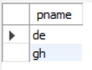

**LAB – 7 & 8**

1. Find the complete details of the projects ordered by client no ‘C02’.

select * from project where clno = 'c02';

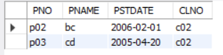

1. Find the dependent name, dependent relation and date of birth of dependents of employee named ‘c’.

select dpname, dprelation, dpdob from dependent natural join employee where ename = 'c';

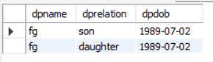

1. Retrieve or find the employee name, employee salary, department name for the employees whose department is located at Ggn.

select ename, esal, dname from employee natural join department where dloc = 'Ggn';

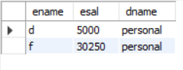

1. Find the employee numbers who are working on the project named ‘cd’.

select eno from project natural join proj_alloc where pname = 'cd';

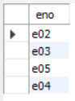

1. Find the project names which are ordered by ‘def’ client name.

select pname from project natural join client where clname = 'def';

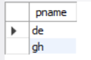

1. Find the employee name for the employees working for department ‘d01’ or who work on project number ‘p03’. (Use set operation).

select distinct ename from employee natural join proj_alloc where (dno = 'd01') or (pno = 'p03');

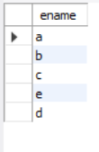

1. Find the employee name for the employees who live in ‘Fbd’ and also have dependents. (use set operation).

select distinct ename from employee natural join dependent where eadd = 'Fbd';



1. Find client names who have ordered projects which involve any of the employees ‘E02’ or ‘E04’ or ‘E07’.

select distinct clname from client natural join proj_alloc natural join project where eno in ('e02', 'e04', 'e07');

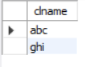

1. Find the department names and their corresponding department head names for the departments located at delhi.

select distinct dname, ename from department natural join employee where (dloc = 'Delhi') and (dhead = eno);



1. Find the employee name for the employees who have salary more than 25000 and who do not live in ‘fbd. (use set operation)

select ename from employee where (esal > 25000) and (eadd != 'Fbd');

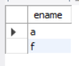

1. Find the project name for the projects which have been ordered by client c02 and have employees living in fbd working on them.

select distinct pname from project natural join employee natural join proj_alloc where (clno = 'c02') and (eadd = 'Fbd');

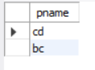

1. Find the client name of the clients who have ordered projects on which employees belonging to department d03 work.

select distinct clname from client natural join employee natural join proj_alloc natural join project where (project.clno = client.clno) and (employee.dno = 'd03');

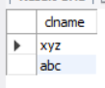

1. Find the employee name and their dependent name for the employees who are working on project named bc.

select distinct ename, dpname from employee natural join dependent natural join project natural join proj_alloc where pname = 'bc';

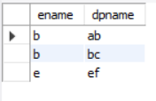

1. Find the project name for the projects who have either been ordered by client no c02 or have employees belonging to marketing Department working on them. (use set operation).

select distinct pname from project natural join department natural join proj_alloc natural join employee where (clno = 'c02') or (dname = 'marketing');

